Rights For Bendigo Residents
November 19, 2014 ·
On the 11th November 2014, Remembrance Day, the City of Greater Bendigo council launched a Human Rights Charter that is to be implemented across the Bendigo region.
What most people do not realize is that this particular Human Rights charter was created by the detached, overpaid, arrogant and unaccountable executive committee at the City of Greater Bendigo and the charter is specific to Bendigo alone.
Instead of adopting the existing Victorian Human Rights charter, they havespent Bendigo ratepayer’s money to create their own Human Rights charter without consultation and without the consent of Bendigo Residents.
They have done this without accountability for the unnecessary waste of our money and without Bendigo residents understanding what is being imposed on them.
It would be very reasonable for the residents of Bendigo to consider the actions of the Bendigo council executives to be unlawful and unconstitutional.
The Human Rights Commission, the Equal Opportunity Commission and the City of Greater Bendigo executives were contacted in writing prior to the launch to advise that their conduct was a violation of the rights of Bendigo residents and a violation of the very human rights legislation that they espouse to uphold.
Despite their acknowledgement of their receipt of this warning, they launched the Bendigo Human Rights Charter on the 11th November 2014. What an insult to Australians, Bendigo residents and our brave diggers doing this on Remembrance day at 11.15am, when this day is set aside to remember our diggers who fought valiantly for our freedom under the Australian Flag.
Bendigo residents still do not understand what this means for them and that is unconscionable.
Top of Form

Rights For Bendigo Residents
November 19, 2014 ·
Our hard earned money is to be allocated by City of Greater Bendigo executive, Pauline Gordon to fund a Community Grant for a Queer Film Festival.
While families are struggling to put food on the table and when our city’s infrastructure is being neglected, we have these arrogant, overpaid, irresponsible council executives squandering our money on frivolous, wasteful and irrelevant, hare brained agendas that serve no other purpose than to pander to the sexual choices of some individuals.
Enough is enough! It’s time for a clean out at the Bendigo council. It’s time to take a wire brush and disinfectant to the stinking rot that is filtering from the head down in Bendigo.
Our group is in no way portraying homophobic views, each person is entitled to their own sexual preferences, however, we do not condone our own money being spent on the whim of Pauline Gordon or any of the other self-serving council members who push their own agenda, rather than take residents requirements and wishes into account.

Rights For Bendigo Residents
November 20, 2014 ·
This is part of the agenda of the council to make Bendigo the inter faith tourist centre.
They are trying to create a tourism draw card using the biggest gothic cathedral, the biggest wooden structured church, the biggest Buddhist stupa and the proposed biggest mosque in Australia.
The recent announcements of the upgrade of the East Bendigo airport will facilitate the pilgrimage of Islamic followers from all over the world as the airport is on the doorstep of the proposed mosque.
It is delusional to think that all faiths, all cultures and all ideologies will be compatible just because the executives at Bendigo council want to exploit the inter faith agenda and expect everyone to play nice.
History clearly shows that this is not the case and that certain ideologies will never integrate.

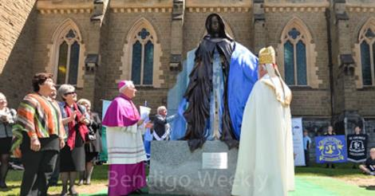

Bendigo Weekly - News
The review is needed because, according to the State Government, 40 per cent of the forecast growth between 2006 and 2031 had already been realised.
BENDIGOWEEKLY.COM.AU|BY DESIGN EXPERTS (WWW.DESIGNEXPERTS.COM.AU)

Rights For Bendigo Residents added 2 new photos.
November 20, 2014 ·
Page 2 shows Sandhurst Trustees (Bendigo Bank) being the custodian for MCCA Sharia Finance
Page 5 shows a fatwa for Sharia law in Australia
Whole document can be viewed at
http://www.mcca.com.au/…/58…/ufiles/MCCA_Income_Fund_PDS.pdf

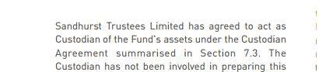

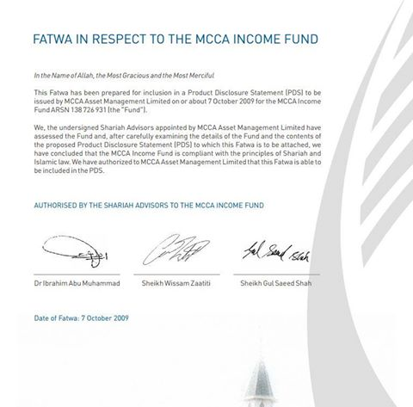

Top of Form
Rights For Bendigo Residents
November 21, 2014 ·
Ask yourself..........

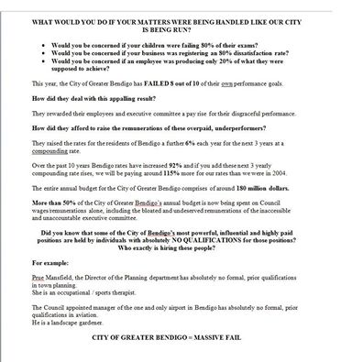

Top of Form
Rights For Bendigo Residents
November 23, 2014 · Edited ·
VCAT EXPOSED Dated 2006, however, it goes to show the corruption in VCAT has been going on for far too long now. Time it was stopped.
www.sos.asn.au
SOS.ASN.AU

Rights For Bendigo Residents
November 24, 2014 · Edited ·
Bendigo Residents have a Problem

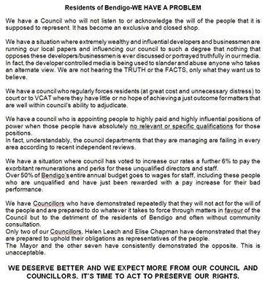

Rights For Bendigo Residents
December 8, 2014 ·
Below is a copy of emails sent to Craig Niemann, Mark Weragoda, Barry Lyons, James Williams, Peter Cox and Lisa Ruffell on Wednesday 3rd December 2014 and Thursday 4th of December 2014. As to date none of these people have replied to this email. We as Bendigo Residents, have every right to challenging Mark Weragoda, Barry Lyons, James Williams, Peter Cox, Lisa Ruffell and Rod Fyffe about their direct and indirect, current and future interests in the mosque development. These Councillors are being paid by us and should be doing the right thing by us, however, they are only serving themselves. With any interest in these developments, must first declare their interest and then they must abstain from voting. If the correct procedure was followed on the 18th June 2018, the mosque would never have been approved.
______________________________________________
3rd December 2014
Dear Councillors Cox, Ruffell, Williams, Lyons and Weragoda,
It has been brought to our attention that a number of Councillors are involved in developments and proposed developments and other interests in the region of the proposed mosque development at 9 Rowena Street, East Bendigo and that some of you also have interests involving the Bendigo airport.
As you well know, you have all been asked about your interest status in relation to these areas on numerous occasions prior to today, including just recently when we met with the newly appointed Mayor, Peter Cox.
We require full disclosure and discovery of these interests, whether they be direct or indirect as a matter of priority by MIDDAY TODAY please.
Should you fail to supply this information as requested today and previously, you may be required to provide these details in a court of law.
Thank you,
Julie Hoskin
_________________________________________________
4th December 2014
Dear Mr Niemann,
I refer to the email correspondence (as attached) that was forwarded for your attention early yesterday morning, Wednesday 3rd December 2014 and the subsequent issues that were raised over the past few days at VCAT in relation to the proposed mosque development and the violations of the Geneva Human Rights Charter/Convention to which Australia is a signatory.
It would appear that the City of Greater Bendigo is in breach of the Human Rights Charter insofar as its conduct toward the residents of Bendigo is concerned, particularly in relation to the supply of information and disclosure to the public of complete and accurate information pertaining to planning and other serious matters.
It would appear that the City of Greater Bendigo is complicit in a number of violations of not only the Human Rights Charter but also violations of the laws of the land, including those that would seem to involve serious matters of civil and criminal law, which appear to implicate a number of current Bendigo Councillors and prominent businessmen.
I note that you have once again failed in your duty to acknowledge or to respond to correspondence that is of significant public interest and concern.
Again, I invite and urge you to acknowledge and to respond with satisfactory and relevant information and answers to my previous correspondence in order to address the issues that have been forwarded for your urgent attention.
I await your prompt response with anticipation.
Thank you,
Julie Hoskin

Rights For Bendigo Residents in Bendigo, Victoria.
December 11, 2014 ·
Bendigo Human Rights Charter

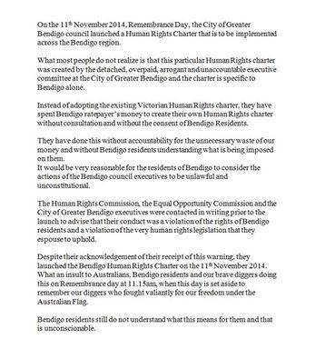

Rights For Bendigo Residents
December 12, 2014 ·
Our president received this lovely 'anonymous' phone call this morning. Clearly the person didn't think about their phone number being displayed when they made the call.

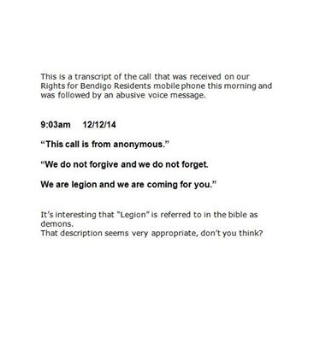

LikeComment
Share

Rights For Bendigo Residents
December 12, 2014 ·
Multiculturalism

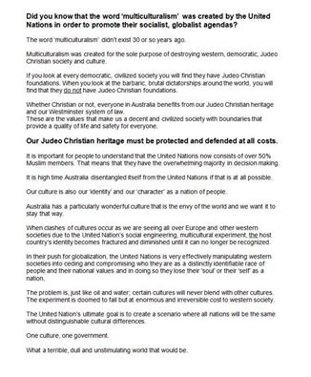

Rights For Bendigo Residents
February 21 ·
It is your turn to speak up and make a change. United we stand.

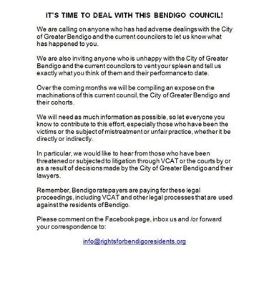

Rights For Bendigo Residents
February 27 ·
Vote of no confidence coming for these 7.

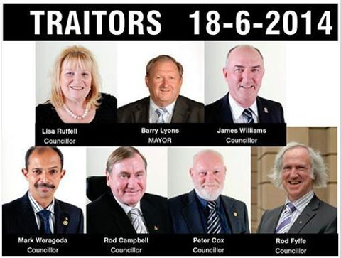

LikeComment
Share

Rights For Bendigo Residents
March 10 ·
COUNCILOR MARK WERAGODA'S ILLEGAL CONDUCT.

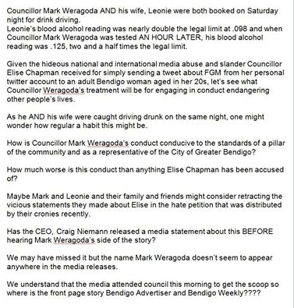

Rights For Bendigo Residents
March 11 ·
Indeed

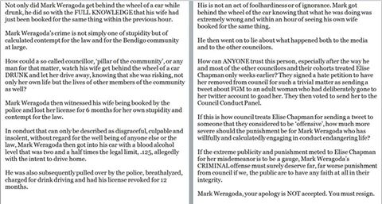

Rights For Bendigo Residents
March 11 ·
Not only did Mark Weragoda get behind the wheel of a car while drunk, he did so with the FULL KNOWLEDGE that his wife had just been booked for the same thing within the previous hour.
Mark Weragoda’s crime is not simply one of stupidity but of calculated contempt for the law and for the Bendigo community at large.
How could a so called councillor, ‘pillar of the community’, or any man for that matter, watch his wife get behind the wheel of a car DRUNK and let her drive away, knowing that she was risking, not only her own life but the lives of other members of the community as well?
Mark Weragoda then witnessed his wife being booked by the police and lost her license for 6 months for her own stupidity and contempt for the law.
In conduct that can only be described as disgraceful, culpable and insolent, without regard for the well being of anyone else or the law, Mark Weragoda then got into his car with a blood alcohol level that was two and a half times the legal limit, .125, allegedly with the intent to drive home.
He was also subsequently pulled over by the police, breathalyzed, charged for drink driving and had his license revoked for 12 months.
His is not an act of foolhardiness or of ignorance. Mark got behind the wheel of the car knowing that what he was doing was extremely wrong and within an hour of seeing his own wife booked for the same thing.
He then went on to lie about what happened both to the media and to the other councilors.
How can ANYONE trust this person, especially after the way he and most of the other councilors and their cohorts treated Elise Chapman only weeks earlier? They signed a hate petition to have her removed from council for such a trivial matter as sending a tweet about FGM to an adult woman who had deliberately gone to her twitter account to goad her. They then voted to send her to the Council Conduct Panel.
If this is how council treats Elise Chapman for sending a tweet to someone that they considered to be ‘offensive’, how much more severe should the punishment be for Mark Weragoda who has willfully and calculatedly engaging in conduct endangering life?
If the extreme publicity and punishment meted to Elise Chapman for her misdemeanor is to be a gauge, Mark Weragoda’s CRIMINAL offense must surely deserve far, far worse punishment from council if we, the public are to have any faith at all in their integrity.
Mark Weragoda, your apology is NOT accepted. You must resign.

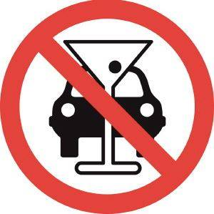

Rights For Bendigo Residents
March 14 ·
Let the council hear your thoughts and feelings on the matter of Mark Weragoda and his recent behavior and their supposed punishment. The council might be happy to sweep it under the carpet, but we as residents certainly are not.
We would like to urge anyone who is not satisfied with the recent punishment, or lack there of to Mark Weragoda for his illegal activity and lies, to email members of the council. Listed below are the email addresses for the councilors and the Mayor.
It is important to only state the issues relating to Mark Weragoda and not to compare his actions or punishment to Elise Chapman's actions or punishment. If you mention Elise Chapman in the same letter/email, it will be disregarded.
Mayor Peter Cox: p.cox@bendigocouncillors.org.au
Cr Helen Leach: h.leach@bendigocouncillors.org.au
Cr Lisa Ruffell: l.ruffell@bendigocouncillors.org.au
Cr Rod Fyffe: r.fyffe@bendigocouncillors.org.au
Cr Elise Chapman: e.chapman@bendigocouncillors.org.au
Cr James Williams: j.williams@bendigocouncillors.org.au
Cr Barry Lyons: b.lyons@bendigocouncillors.org.au
Cr Rod Campbell r.campbell@bendigocouncillors.org.au
PLEASE SHARE THIS POST TO FAMILY, FRIENDS AND WORKMATES

Rights For Bendigo Residents
March 18 · Edited ·
YOUR HELP NEEDED PLEASE !!!
We need people who live in the Bendigo Area to print off our petition and collect as many signatures as possible before the next Council meeting on Wednesday 25th March (next week).
Please do your bit to help by asking your neighbours, friends, family and work colleagues to sign this petition. This petition is to ensure the COGB is honest, transparent and accountable to the residents and rate payers of Bendigo.
...See More

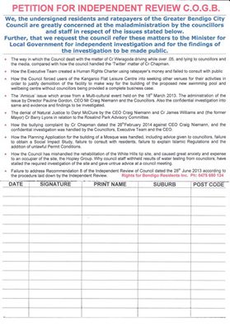

Rights For Bendigo Residents
May 18 · Edited ·
PART 2 OF 2 -- MORE ON THE ISSUES RAISED AT VCAT AND MORE ABOUT THE AUSTRALIAN ISLAMIC MISSION INC.
1. The City of Greater Bendigo and their lawyers and the lawyers acting for the Australian Islamic MIssion inc. tried repeatedly to use the Human Rights Charter to suggest that we were in breach of their human rights by trying to deny them the right to build the biggest mosque in the southern hemisphere. They didn't realize that our lawyer, Robert Balzola is an expert on the Human Rights Charter. He pointed out that the City of Greater Bendigo AND the Australian Islamic Mission inc. were incorporations, NOT people. He said that the Human Rights Charter only covers persons and that the only 'person' who was a party in the VCAT matter was Julie Hoskin, therefore only her human rights were protected. He went on to say that the City of Greater Bendigo has NO human rights and the Australian Islamic Mission inc. has NO human rights either. LOL!
2. Council tried to deceive residents and VCAT by implying that there was no relevance to the mosque site and the surrounding industrial land. They tried to say that the proposed mosque site would have no impact on the industrial supply of land in the area. They tried to hide the fact that the Australian Islamic Mission inc also owned ALL of the surrounding supply of industrial land. In fact, all the land was bought at the same time, just after the council voted to accept the mosque proposal on the 18th June 2014.
3. The permit applicant supplied council with further addendums to the permit in February-March 2014. When they did this, they did not supply neighbouring residents with copies of these addendums which included suggestions of further extensions to thedevelopment and an Islamic school. The implications of this could mean that an entirely new permit application should have been submitted with the appropriate statutory advertising and appropriate planning procedures followed.
4. Despite repeated requests to the planning department, no internal drawings of the minaret were provided to show whether or not the structure would be a working minaret or just 'symbolic' as the City of Greater Bendigo and the Australian Islamic Mission inc. were suggesting.
5. The QC acting for the Australian Islamic Mission inc. said that the call to prayer would be sent out via text message and that the minaret would not be used for the call to prayer. (Dubai, Qatar, Tripoli, Istanbul are all tech savvy middle eastern cities with the capacity to send text messages, yet they still have the call to prayer.)
6. At the council meeting on the 18th June 2014 when councillors voted to accept the mosque planning application, the Director of planning, Prue Mansfield stated the permit did not allow for the minaret to be used for the call to prayer but that AFTER the mosque was built, they could apply to use it for that purpose.
7. Chris Duckett of the planning department deliberately omitted sending requests from the manager of the airport about critical information that was required from the Civil Aviation Safety Authority (CASA) to enable them to form an accurate opinion on the location and height of the proposed minaret in relation to the airport and the secondary runway.
8. Due to its height and proximity to the airport runway, which is only 800 meters from the proposed site of the minaret, the minaret would be required to have a warning beacon on top. This beacon would need to be so bright that it could be easily seen by incoming aircraft.
This would cause further enormous disruption to those living in the adjacent residential neighbourhood.
9. Council and the Australian Islamic Mission inc. claimed that the boundaries of the proposed mosque site were at least 35 meters from the boundaries of the nearest residential property, therefore meeting the required buffer zone. It is much less than 35 meters.
10. Chris Duckett refused to provide exact figures on the size of the entire footprint of the proposed mosque deveopment. He told us to get a ruler and work it out ourselves.
11. When Council was asked prior to VCAT to clarify whether or not the sports hall was to be a 2 storey construction, they said it was only a single storey construction. At VCAT their expert witness town planner stated vehemently that it was to be a 2 storey construction. When council was asked if the sports hall was being built with the capacity to add a second storey floor, they refused to answer.
12. Our lawyers argued that the size and construction of the 2 storey sports hall lent it to being easily used as a second prayer hall with separate areas for men and women.
13. The Council and the Australian Islamic Mission inc. claimed the 2 storey sports hall would be available for public use between prayer times but they would not stipulate the finish times for their prayers to enable anyone to assess how a sports game could possibly be held within those time frames. Furthermore, Islamic prayer times are not set times as they vary in accordance with two astronomical measures.
14. The REAL variance in the prayer times throw all of the traffic and parking reports out the window.
15. The reports contained in the planning file stipulated that a maximum of only 25 people would be able to use the sports hall at any one time.
16. The Australian Islamic Mission inc. would not explain what kind of sports would be able to be played in the sports hall given the rigid time constraints and extreme limitations of numbers of people who could participate at any given time or who would be able to use the facility "in accordance with Islamic guidelines".
17. The Council and the Australian Islamic Mission inc. failed to provide details of who and what strain of Islamic ideology the Imam would adhere to eg: Wahhabism or whether he would be Sunni or Shiite.
It is our understanding that, just like the Australian Islamic Mission inc in Sydney, the Imam will be Sunni and that it will be Wahhabism that is intended to be practiced in Bendigo. This is the most extreme form of Islamic ideology.
18. Our lawyers and expert witnesses argued that a mosque is NOT the same a church. It is a seat of government and a legal/Sharia centre where marriages, divorces, judgements and so forth are conducted. A mosque operates almost 24 hours a day, 7 days a week, not just a few hours on a Sunday or the odd weekday.
There are 5 specified prayer times starting from around 5 am to 11 pm every single day of the week. The impact on the neighbouring residential area would be far, far more significant than if it was a church.
19. The issue of the impact to the neighbourhood amenity was raised. The impact would be huge and detrimental to a low density residential neighbourhood and the equine businesses that are in that area. People's livelihoods will be negatively impacted.
20. The persons who are listed on the new titles of the land at East Bendigo for the proposed mosque are Sheikh Rabih Baytie, President of AIM and Dr Seyed Sheriffdeen, Secretary of AIM. The address that is listed is that of the Maidstone mosque in Melbourne. One of the attendees of the Maidstone mosque is Musa Cerantonio, otherwise known as the "Fake Sheikh" who was deported from the Phillipines last year. He is recognised as the poster boy for Islam and is one of the main proponents recruiting many young men to fight with ISIS.
21. The Maidstone address is also chapter 2 of the Australian Islamic Mission inc. Chapter 1 is in Lakemba, Sydney. Their former name is Juma'at Islamiah. They changed their name to the Australian Islamic Mission inc AFTER the Bali bombings. Abu Bakr Bashir, the orchestrator of the Bali bombings was a guest speaker at the Sydney branch of Juma'at Islamiah just prior to the terror attack in Bali. The twin brothers who were running the branch in Sydney were planning terror attacks in Sydney and Melbourne. One of them fled back to Indonesia after the Bali attacks and the other one was caught, charged and deported back to Indonesia. They have since told reporters that Australia was being used as the financial base for Juma'at Islamiah in Indonesia and that while in Australia they had trained up dozens of Jihadists who are still here.

LikeCommentShare

Rights For Bendigo Residents
July 28 · Edited ·
WE'RE BACK!! THANK YOU FOR YOUR PATIENCE.
As you are probably aware, other than the mosque issue, Rights for Bendigo Residents inc. has been dealing with a number of other serious issues at VCAT.
"Voices of Bendigo" has a great article on their Facebook page about what REALLY happened at VCAT yesterday. Please take the time to read it.
We are now in a position to tell you that the Bendigo Council and its executives and a group of individuals who arrogantly refer to themselves as “the leaders of Bendigo” have an agenda in store for our city that will render Bendigo unrecognizable if they are not stopped.
These wealthy, unelected, narcissistic, self appointed “leaders of Bendigo” are well connected in both political and legal circles and have held undue influence with the City of Greater Bendigo and our local media for many years.
What is being outworked in the shadows and without the knowledge or consent of the residents and ratepayers of Bendigo will absolutely shock you. It will change the face of Bendigo forever.
No one will escape the impact of what is being proposed, yet we have been repeatedly lied to and deceived and we’ve been given NO SAY whatsoever in what these traitors are doing.
Those involved stand to make many millions of dollars through the corrupt exploitation and abuse of the residents and ratepayers of Bendigo. This group consists of the SAME people who are pushing for the biggest mosque in Australia at Bendigo East and who have publicly slandered anyone who has opposed it. We know who these people are, we have their names and the councillors and businesses who are involved with them.
The monstrous proposed mosque development is only one of the key elements in the master plan.
None of this would be achievable without political and legal complicity.
Understand this, if what is being proposed was a good thing for Bendigo and if they believed that residents would embrace their plans, THERE WOULD BE NO NEED TO LIE, DECEIVE AND WITHHOLD THE TRUTH ABOUT IT?
THEY KNOW BENDIGO RESIDENTS WILL NOT ACCEPT WHAT THEY ARE DOING AND THEY KNOW IT WOULD BE VEHEMENTLY REJECTED. This is about breathtaking arrogance, greed and selfish ambition at the expense and to the detriment of everyone else.
We are consulting with our legal team and will be releasing more information shortly.

Rights For Bendigo Residents
August 1 · Edited ·
·
WHAT IS BENDIGO COUNCIL EXPOSING US TO AND WHO ARE THE AUSTRALIAN ISLAMIC MISSION INC?
The Australian Islamic Mission Incorporated are the new owner's of the proposed mosque site at East Bendigo but who are they and what is their history?
What due dilligence and investigation did they conduct and what has the City of Greater Bendigo Council done to ensure the safety and wellbeing of the residents of Bendigo PRIOR to approving a permit to build a mosque for the Australian Islamic Mission incorporated?
The answer: NOTHING!
FOR THOSE WHO STILL THINK THE AUSTRALIAN ISLAMIC MISSION INCORPORATED IS OKAY, SEE FOR YOURSELF WHAT THEIR NAME WAS BEFORE IT WAS CHANGED IN 2004.
JUMAAT DAWAAH ISLAMIAH is simply a variant name of the Indonesian Jumaati group which includes Jumaah Islamiah. Originating from Malaysia it soon spread into Indonesia and Jumaah Islamiah became known to be the terrorist group responsible for the Bali bombings.
Just prior to the Bali bombings, Abu Bakr Bashir the leader of the Bali bombers was a guest speaker in Lakemba, Sydney. The twin, Indonesian brothers who were running the Muslim group fled Sydney after the bombings.
One managed to escape to Indonesia but the other brother was arrested in Perth, charged with planning terror attacks in Sydney and Melbourne and then deported back to Indonesia.
In recent interviews they told the reporters that they had trained up at least a dozen Jihadis who were still in Australia.
BENDIGO COUNCIL IS AWARE OF THESE FACTS BUT HAVE IGNORED THEM.
Chapter 2 of the Australian Islamic Mission Incorporated is based at the Maidstone Mosque in Melbourne. Sheikh Rabih Baytie and Sayed Sheriffdeen appear on the title of the East Bendigo land as the President and Secretary of AIM.
This is one of the attendees who frequents the Maidstone mosque. An indication of what Bendigo can expect.
http://www.abc.net.au/…/wife-of-arrested-islamist-p…/5592796

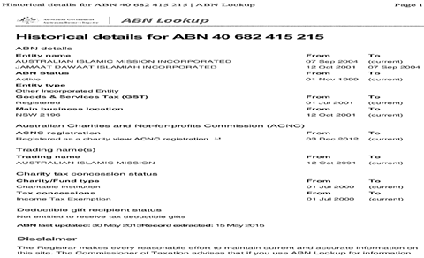

Rights For Bendigo Residents
August 11 ·
An Indonesian Islamic group is trying to force Bendigo to accept the biggest Islamic mosque in Australia via a corrupt local Council and yet Christian Churches in Indonesia are not accepted.
WHO'S THE RACIST AND BIGOT NOW OR DOES IT ONLY GO ONE WAY? POT, KETTLE, BLACK much???
http://www.ucanews.com/…/in-indonesia-muslim-group-pr…/74053

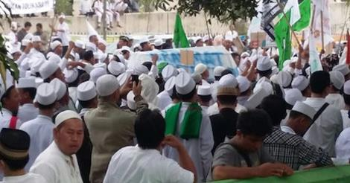

In Indonesia, Muslim group protests against planned church construction - ucanews.com
In Indonesia, Muslim group protests against planned church construction. Restrictive laws make it difficult for congregations to build places of worship
UCANEWS.COM

Rights For Bendigo Residents
August 16 · Edited ·
MAYOR COX'S NON DECLARATION OF COUNCILLOR INTERESTS.
As we have stated in previous posts, under the rules of the Councillor Code of Conduct, Bendigo Councillors must declare their DIRECT and INDIRECT interests which includes close family and business interests.
Councillors are NOT to vote on issues that they have a direct or indirect interest in.
As Mayor, Peter Cox gets two votes on isses that are presented before council to be approved or rejected.
We know of at least SIX Councillors, including Mayor, Peter Cox who have NOT declared these interests on the Councillor's register of interest declarations that are held at the executive office at the City of Greater Bendigo.
Yet these same Councillors have repeatedly voted for or against issues that were before council when they had no right to do so.
The Executive officers KNOW what is happening but they have not taken ANY action against these Councillors who are acting so reprehensibly and corruptly.
The Executive officers are excusing and facilitating this corruption and abuse of residents by these wicked Councillors.
The CEO, Craig Niemann signed off on these false declarations of Councillor interests.
Mayor, Peter Cox has voting rights and is a founder and a lifetime member of Future Employment Opportunities which also incorporates Go and Grow Gardens, Side Track Canteen, On Track Training and Employment, .
He is also involved in Eaglehawk Recycling, Community Recycling AND MORE.
His partner, Annette Wiles is also employed in these business interests and has been listed as Executive Personal Assistant.
She has also been involved/employed in the City of Greater Bendigo Strathfieldsaye recycling business as well as the Eaglehawk Recycling centre.
In Mayor, Peter Cox's Councillor Register of Interests, no mention is made of his above interests.
Future Employment Opportunities has just recently been listed as a 'Charitable Organisation' and lists the following as those whom the 'Charity' benefits. It includes "Migrants, Refugees and Asylum Seekers" and "Ethnic Groups".

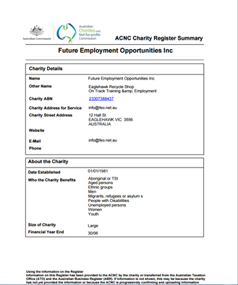

LikeCommentShare

Rights For Bendigo Residents
October 5 ·
GUESS WHOSE VEHICLE WAS PARKED ALL EVENING IN THE TAXI RANK OUTSIDE THE REJECT SHOP IN HARGREAVES STREET LAST WEEKEND?
NONE OTHER THAN THAT OF COUNCILLOR MARK WERAGODA.
HOW MUCH MORE BRAZEN FLAUNTING OF THE LAW SHOULD BENDIGO RESIDENTS HAVE TO TOLERATE FROM THIS INDIVIDUAL BEFORE HE IS BOUGHT TO ACCOUNT?
WHILE HIS DAUGHTER ATTENDED TO HER STALL AT THE MOONLIGHT MARKET, MARK WERAGODA'S VEHICLE REMAINED PARKED IN THE TAXI RANK ALL NIGHT WHILE TAXIS WERE FORCED TO FIND PARKING ELSEWHERE.
CLEARLY, MARK AND HIS FAMILY CONSIDER BENDIGO TO BE THEIR OWN PERSONAL FIEFDOM WHERE THE RULES ONLY APPLY TO US PEASANTS.
IT WOULD BE INTERESTING TO KNOW WHO THE DRIVER WAS ON THE NIGHT AS MARK LOST HIS LICENCE AFTER BEING CAUGHT DRINK DRIVING EARLIER THIS YEAR.
WHAT A GRUB!

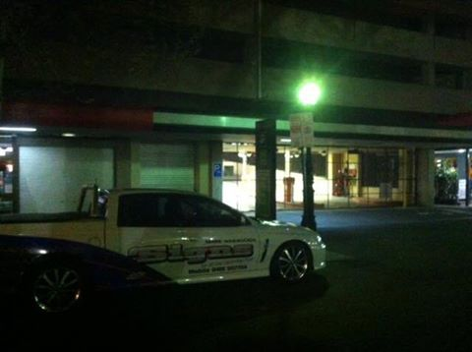

Rights For Bendigo Residents
October 26 ·
SENT IN BY A SUPPORTER.
Saw this today! You've probably seen it, but was off a friends site that I had no idea supported the same as I!

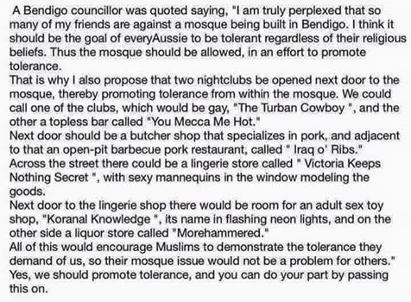

Rights For Bendigo Residents
November 7 at 4:48pm · Edited ·
We have prepared this response to queries put to us about the ALLEGED numbers of Muslims in Bendigo and the ALLEGED maximum attendees to the proposed mega mosque at East Bendigo.
The mosque plans as they CURRENTLY stand have the capacity to accommodate at least 2000 attendees, however, there are further extensions and other facilities planned as well that Bendigo residents have not been told about by Council.
They also want to build in stages which is a tactic used to facilitate further changes to a planning application.
These further extensions and changes to the plans are mentioned in documents that were added to the planning file later and they include an Islamic school.
Nothing has been quantified or clarified as it should have been and VCAT ignored all of these issues that were raised repeatedly during the course of our hearings.
Our lawyers and political contacts have informed us that this mosque is to become the biggest mosque in Australia, if not the southern hemisphere.
In Bendigo, we have the biggest gothic cathedral in the southern hemisphere, the biggest buddhist stupa in the southern hemisphere, the biggest wooden structured church in the southern hemisphere, the biggest Chinese dragon in the southern hemisphere etc, etc so it stands to reason that this mosque will eventually become the biggest in the southern hemisphere as well.
Daniel Andrews (Premier of Victoria) has stated in the media that Bendigo is to become the inter faith capital of the world and Victoria is to become the multi cultural capital of the world.
According to the planning permit documents and the statements of Chris Townshend, the QC acting for the Australian Islamic Mission inc. there are only 250 Muslims in the Bendigo 'region'. The Bendigo 'region' is an enormous area of 3,048 square kilometers which takes in many small towns and surrounding rural areas. 'Region' does not mean Bendigo city itself.
Again, according to the planning documents and the QC for AIM, of the alleged 250 Muslims (and I believe that figure to be an exaggeration) only 35 are practicing Muslims who attend the prayer halls (there are multiple) provided for them at Latrobe university.
Of those 35 practicing Muslims, many are NON domiciled students and itinerant workers attending the university and other places in Bendigo.
They aren't even Bendigo residents.
There are literally only a handful of practicing Muslims here, although we've noticed over the past 6 months or so, those numbers are increasing.
The question needs to be asked, "Why are there only 35 practicing Muslims in the 'region' ?"
The answer is simple. Many Muslims leave their countries of origin to escape the control and abuse that organisations such as AIM inc represent.
They come here to be free of it.
The totally fabricated figure of '375' MAXIMUM attendees for the proposed mega mosque was derived by applying false ABS statistics to a guestimate of possible 'family' groups that may attend.
Instead of using proper planning procedures to accurately estimate the square meter 'capacity' of the building to accommodate attendees, they suggested that they expect 150 families to attend. This is outrageous.
They then applied ABS statistics from Bendigo anglo Australian families which are on average 2.5 people and attributed that average number to the expected 150 Muslim families and arrived at the figure '375'.
Yet if you take the ABS statistics for average family sizes for places such as Lakemba and Punchbowl who have approximately 40% Muslim population, the average family sizes are around 3 times higher than those in Bendigo.
That means that every report and document relied upon in the planning process that used these FALSE and deliberately DECEPTIVE figures of '375' MAXIMUM attendees to the proposed mega mosque is manifestly incorrect.
Islamic Mission is a global organisation with direct links to the Muslim Brotherhood and Hamas.
They are connected to an Islamic charitable organisation called 'Human Appeal International' which is also known internationally as a channel for funding to Hamas and the Muslim Brotherhood.
'Human Appeal International' receives significant "donations" from the likes of 'Halal Certification Australia'. During a recent 4 Corner's interview, Mohamed El-Mouelhy, Chairman of Halal Certification Authority, Australia stated that he donates to 'Human Appeal International'.
What most people don't know is that the Director of 'Human Appeal International' in Sydney Road, Coburg is Sheikh Rabih Baytie who is also the President of Chapter 2 of the Australian Islamic Mission Incorporated and his name appears on the title for the land for the proposed mega mosque at East Bendigo.
'Human Appeal International' is located at 149 Sydney Road, Coburg and is only a few doors down from 'MCCA Sharia finance and investments', 169 Sydney Road, Coburg.
The lender for the funding for the proposed mega mosque at East Bendigo is listed on the titles as 'Sandhurst Trustees', a wholly owned subsidiary of 'Bendigo Bank'.
'Sandhurst Trustees' is also the custodian (or front) for 'MCCA Sharia Finance and Investments' which means the funding for the proposed mega mosque in Bendigo has been financed by Sharia finance.
Sheikh Rabih Baytie is also the Sheikh at the Maidstone mosque in Melbourne where Musa Cerantonio attends. They are Sunni Muslims and practice Wahhabism which is the most extreme form of Islam originating directly from the House of Saud.
Musa Cerantonio was deported from the Phillipines in 2014 and given the title "the Fake Sheikh". He has been a MAJOR proponent of ISIS recruitment both in Australia and internationally.
This is what is being proposed for Bendigo without any consultation with Bendigo residents and without a MANDATORY social impact study having been conducted.
Hope this assists to quell the dissenters.

LikeCommentShare

Rights For Bendigo Residents shared a link.
November 13 at 2:15am ·

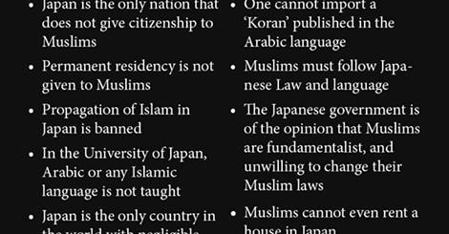

Japan imposed these severe restrictions on muslims…this is why they’re the only country on earth...
Japan imposed these severe restrictions on muslims…this is why they’re the only country on earth not having problems Nov 10, 2015by admin in MIDDLE EAST &…
JEWSNEWS.CO.IL

Rights For Bendigo Residents
November 14 at 8:25pm ·
DENIALS, DIVERTING BLAME, MORE DESPICABLE VICTIMIZATION CLAIMS AND JUSTIFICATION FOR TERRORIST ATTACKS BY MUSLIMS.
"Some thoughts on ‪#‎ParisAttacks‬
1. Attacking innocent civilians whether in Paris, London, Gaza or Syria etc is completely unjustified and unislamic.
...Continue Reading

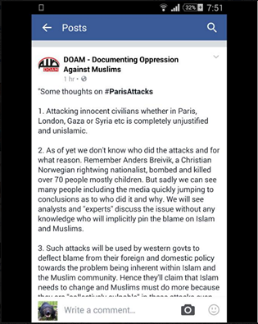

Rights For Bendigo Residents
November 14 at 8:52pm · Edited ·
IN ALL OF AUSTRALIA'S HISTORY, NO OTHER DEMOGRAPHIC HAS HAD THE CAPACITY TO ALTER THE ENTIRE PSYCHE OF OUR NATION IN SUCH A NEGATIVE WAY AS ISLAM HAS.
IT REPRESENTS NOTHING GOOD OR RIGHT AND IT HAS NO PLACE IN OUR COUNTRY.
FROM A SUPPORTER:
This is now the country we live in, where terrorism is the norm and appropriate warnings are put out by our government... All thanks to Islam. How did it get to this? Our country is no longer the way it was when I was growing up, what's it going to be like for my children in 20 years time. Our country should be one of the easiest lands for border control given the only way to sneak in is by water. Oh wait we let them in by the 1000s. Islam and its beliefs are now a disease in this country that is spreading like wild fire. Please , please let there be no mosque built in this town. Nothing good can come from it.

